What have you done so far? (Group)

We have decided to make a podcast for the project and decided on the team roles.

What needs to be completed next? (Group)

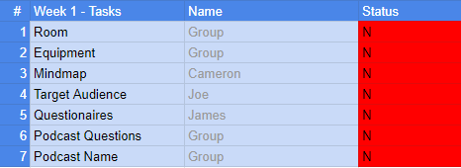

What is your job after this meeting? (Individual)

Joseph -

Finish the Target Audience research.

Cameron -

Finish the creative mind maps for our podcast ideas.

James -

Design the questionnaire about our audience

What have you completed at the end of today’s session? What do you need to complete before the next meeting? (Individual and Group)

The Kanban will be completed at the end of this session by Cameron.

The target audience documentation will be completed by Joseph.

The questionnaire will be completed by James.

The mindmaps will be completed by the group.